

AI-Based Support for Understanding and Analyzing Legal Cases

BSc. in Software Engineering

Nubuhoro Divine

Supervisor: Thadee Gatera

Date:1/22/2026

DECLARATION

This project proposal is my own work. Any ideas or information from other sources have been properly cited. This work has not been submitted for a degree or similar purpose at any other university.

Contents

CHAPTER ONE: INTRODUCTION 1

1.1 Background of the Study 1

1.2 Main Objective of the Study 2

1.3 Specific Objectives 2

1.4 Research Questions 2

1.5 Scope of the Study 3

1.5.1 Time Scope 3

1.5.2 Coverage of the Study 3

1.5.3 Location and Population 3

1.6 Significance and Justification of the Study 5

1.7 Research Budget 6

1.8 Research Timeline (Gantty chart) 7

CHAPTER TWO: LITERATURE REVIEW 8

2.1 Introduction 8

2.2 Historical Background of the Research Topic 9

2.3 Review of Related Work 10

2.3.1 Local Legal Technology Systems 10

2.3.2 International Legal AI Systems 11

2.3.3 Summary of Reviewed Literature 11

2.5 Strengths and Weaknesses of Existing Systems 12

2.6 General Comment and Conclusion 14

CHAPTER THREE: SYSTEM ANALYSIS AND DESIGN 15

3.1 Introduction 15

3.2 Research Design and Development Approach 15

3.2.1 Research Design 15

3.2.2 Development Model 16

3.3 Proposed Model Diagram 17

3.4 Class Diagram 18

3.5 UML Diagrams 19

3.5.1 Use Case Diagram 19

3.5.2 Entity Relationship Diagram (ERD) 21

3.6 System Architecture 23

3.6.1 Overall System Architecture 23

3.6.2 AI/ML Pipeline Architecture 27

3.7 Development Tools and Technologies 28

References 29

List of Tables

Table 1: Research Budget

Table 2: Strengths and Weaknesses of Existing Systems

List of Figures fig1

Figure 1: Gantty chart

Figure 2:Proposed model diagram

Figure 3:Class Diagram  
Figure 4: : Use case Diagram  
Figure 5: ****Entity Relationship Diagram (ERD)****

Figure 6: system archtecure Diagram

Figure 7: AI/ML Pipeline Architecture

List of Acronyms/Abbreviations

• **AI** – Artificial Intelligence

• **NLP** – Natural Language Processing

• **ICT** – Information and Communication Technology

• **NCNM** – National Case Management System

• **IECMS** – Integrated Electronic Case Management System

• **LAF** – Legal Aid Forum

• **UCD** – User-Centered Design

• **AWS** – Amazon Web Services

• **DB** – Database

• **API** – Application Programming Interface

• **OECD** – Organisation for Economic Co-operation and Development

• **UNDP** – United Nations Development Programme

• **R&D** – Research and Development

• **UC** – Use Case

• **1----**\* – One-to-many relationship

• **1-----1** – One-to-one relationship

• \****-----\**** – Many-to-many relationship

• **PK** – Primary Key

• **FK** – Foreign Key

• **UML** – Unified Modeling Language

• **ERD** – Entity Relationship Diagram

• **ML** – Machine Learning

• **AI/ML** – Artificial Intelligence and Machine Learning

• **ISO** – International Organization for Standardization

# CHAPTER ONE: INTRODUCTION

## 1.1 Background of the Study

Access to justice is a fundamental principle of the rule of law and a cornerstone of good governance, ensuring that individuals can resolve legal issues in a fair, affordable, and effective manner (United Nations, 2024). Despite its importance, millions of people around the world face barriers in exercising their legal rights due to limited legal knowledge, complex legal language, and high costs of legal services. Globally, approximately 5.1 billion people lack meaningful access to justice, leaving them vulnerable to unresolved legal problems and inadequate support (United Nations Development Programme [UNDP], 2021).

In Rwanda, access to justice remains a significant challenge, particularly for ordinary citizens. Research indicates that only about 4% of Rwandans consider their knowledge of the law to be high, while the majority either have limited understanding or are unsure of their legal rights (Legal Aid Forum, 2020). Many people rely on informal intermediaries, such as family members or cyber café operators, to help navigate legal procedures, but these individuals are not legally trained, which can result in misinterpretation and poorly presented cases. Existing digital platforms like Amategeko.gov.rw and RwandaLII provide access to national laws, yet they primarily offer legal texts without explaining how these laws apply to everyday situations (Han et al., 2024). Similarly, professional tools such as LexisNexis and Westlaw are costly and complex, making them inaccessible to most citizens (Mowbray et al., 2021).

This study seeks to address this gap by developing Mufashe, an AI-driven mobile platform that helps individuals understand and analyze legal cases in simple, everyday language. The platform aims to provide understandable guidance, suggest possible legal options, and offer alternative ways to handle cases, thereby improving legal awareness and empowering users to interact with legal institutions more confidently.

## 1.2 Main Objective of the Study

**The main objective of this study** is to develop, within three months, an AI-driven digital platform that analyzes users’ legal cases and provides clear, accessible explanations of relevant laws, thereby improving legal awareness and enhancing access to justice for Rwandan citizens.

## 1.3 Specific Objectives

1. To develop a user-friendly and easily accessible AI system that can analyze users’ legal situations and suggest relevant laws, possible legal positions, and alternative ways to resolve cases without going to court.
2. To create clear and simple explanations of laws and possible solutions so that everyone, regardless of education level, can understand their rights and options.
3. To evaluate the platform with at least 30 users, collect feedback, and make improvements to ensure it is easy to use and clearly explains both legal and alternative solutions.

## 1.4 Research Questions

1. How can an AI system be designed to analyze users’ legal situations and suggest relevant laws, legal positions, and alternative ways to resolve cases in a user-friendly and easily accessible way?
2. How can legal information and possible solutions be presented in simple, clear language that is understandable to all users regardless of education level?
3. How effective and accurate is the AI platform in providing legal and alternative solutions, and how well do these align with actual court outcomes?

## 1.5 Scope of the Study

### 1.5.1 Time Scope

The study will be conducted over a period of **three months**, during which the AI platform will be designed, developed, tested, and evaluated with user

### 1.5.2 Coverage of the Study

This study focuses on the design and development of Mufashe, an AI‑driven mobile application aimed at improving legal awareness and access to justice for Rwandan citizens who **are literate and have access to digital tools and the internet**. The target population includes individuals who **know how to read and write**, as they are able to interact with the app’s text‑based interface to input legal concerns and interpret guidance. According to recent data from the National Institute of Statistics of Rwanda, approximately **78.8 % of the population aged 15 years and above are literate**, indicating a broad base of potential users who can engage with written digital content (Statistics gov Rwanda, 2025). In terms of digital access, Rwanda has seen substantial growth in mobile and internet connectivity; there were an estimated **5.01 million internet users by the end of 2025**, equivalent to about **34.2 % of the population** using the internet regularly, and around **13.0 million active mobile connections**, representing roughly **88.7 % of the population** (DataReportal, 2026). These trends show that a significant portion of Rwandans can potentially access a mobile app like Mufashe, especially through widespread mobile connections that many households use for communication and digital services.

### 1.5.3 Location and Population

The *Mufashe* mobile app project is situated within the Republic of Rwanda, a landlocked country in East Africa known for its focus on technology and digital transformation. Rwanda’s estimated national population stood at approximately 14.7 million people in late 2025, with a median age of about 19.9 years, reflecting a predominantly young population (DataReportal, 2026). The country is divided into provinces, districts, and sectors, with the City of Kigali as the capital and most urbanised area, hosting a significant share of the population and acting as a hub for digital services and innovation. Kigali alone has over 1.7 million residents, with some districts showing high population densities, which can influence digital adoption patterns in urban settings (Statistics gov Rwanda, 2025).

The **urban–rural population distribution** shows that approximately **18.4 % of Rwandans live in urban centres** while about **81.6 % live in rural areas** (DataReportal, 2026). This distribution is important for understanding how *Mufashe* will be used across different geographic contexts. Access to digital tools and stable internet connection is generally higher in urban areas such as Kigali, contrasted with rural areas where connectivity and infrastructure are more limited. Household surveys indicate that while a higher proportion of urban households report internet connectivity, rural households lag behind, underscoring gaps in access to digital services (Statistics gov Rwanda, ICT data).

Literacy levels further shape the target population. Latest census data indicate that roughly **78.8 % of Rwandans aged 15 and above are literate**, meaning they can read and write, with literacy rates higher in urban areas (about 89.8 %) compared to rural zones (about 74.2 %) (Statistics gov Rwanda, 2023). This literacy base is crucial for *Mufashe*, as the app relies on users being able to **interpret legal information and interact with text‑based content**.

In terms of digital penetration, around **34.2 % of the population were active internet users** in late 2025, and mobile connections reached approximately **88.7 % of the population**, showing that mobile devices are the **primary channel** through which people access the internet and digital services (DataReportal, 2026). However, internet use varies significantly between urban and rural areas; rural internet usage rates are lower than in cities, largely due to infrastructure and affordability challenges (AllAfrica, 2025). These demographic and digital trends inform the scope of *Mufashe’s* deployment: the app is primarily designed for Rwandans who **can read and write**, possess **access to mobile devices**, and are **connected to the internet or have intermittent connectivity**, enabling them to benefit fully from the app’s AI‑driven legal guidance.

## 1.6 Significance and Justification of the Study

Access to justice is still a big challenge for many ordinary citizens in Rwanda. Most people do not understand the law well, find legal language confusing, or cannot afford professional legal help (Chaudhary, 2026; Watanabe, 2024). Current legal tools and platforms are usually designed for lawyers and professionals, which leaves regular citizens without easy guidance for their cases (Borgesano et al., 2025; OECD, 2025).

This study proposes an **AI-driven digital platform** that explains laws in simple language, offers basic case analysis, and suggests ways to resolve disputes before going to court. Similar AI systems have been used in countries such as India and across Europe, showing that technology can help people understand legal information more easily (Borgesano et al., 2025; Chaudhary, 2026). The platform will also help lawyers and legal aid providers by handling routine case assessments, so they can focus on more complex cases (Watanabe, 2024; Chaudhary, 2026).

Rwanda is already working on digitalizing legal information through online portals, which makes it a good context for this kind of platform (Rwanda Ministry of Justice, 2022). This research addresses the need for solutions that make legal information accessible to more people while considering fairness and ethical issues (Watanabe, 2024). By helping citizens understand their rights, improving access to justice, and supporting legal professionals, the platform can make the justice system more efficient and useful for everyone (Borgesano et al., 2025; OECD, 2025).

## 1.7 Research Budget

| Item | Description | Cost (USD) |
| --- | --- | --- |
| Cloud Hosting | Vercel Pro plan for 6 months to host a live demo. | $30 |
| AI API Credits | OpenAI/Anthropic credits for testing and generating sample legal analyses. | $150 |
| FieldResearch Materials | Local transport, printing, and documentation for case study collection. | $40 |
| Domain & Web Presence | Custom domain and basic hosting for the public research portfolio. | $20 |
| Contingency | Reserve for unexpected costs or additional testing. | $30 |
| TOTAL |  | $270 |

## 1.8 Research Timeline (Gantty chart)

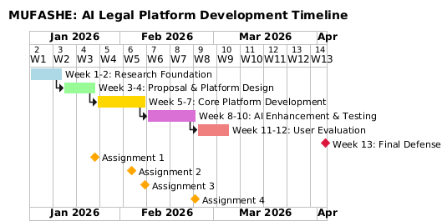

# CHAPTER TWO: LITERATURE REVIEW

## 2.1 Introduction

Access to justice refers to the ability of individuals to seek and obtain a remedy through formal or informal institutions of justice, and it is widely recognized as a key component of the rule of law and equitable development. Research by the Organisation for Economic Co‑operation and Development (OECD) highlights how digital technologies, including artificial intelligence (AI), have potential to support justice systems by enhancing efficiency, transparency, and responsiveness to citizen needs (OECD, 2025). While digital justice tools such as electronic case management systems have improved administrative processes, many individuals still face barriers understanding legal rights and navigating procedures, particularly in contexts with low legal literacy (Legal Aid Forum, 2023). In Rwanda, the use of digital platforms like the Integrated Electronic Case Management System (IECMS) and mobile initiatives for legal texts aims to make justice information more accessible; however, gaps remain in tools that provide intuitive guidance for everyday users (Ministry of Justice, 2024; Africa‑Press, 2025). Emerging AI platforms in Rwanda and elsewhere are being positioned to fill such gaps by offering automated research support, case tracking, and potentially interactive legal information services (Africa‑Press, 2025). Nevertheless, ethical considerations such as fairness, accountability, and data protection are increasingly emphasized in scholarly and policy discussions on AI adoption in justice systems (UNESCO, 2025). This review examines both local and international literature on AI and digital platforms in justice, identifying strengths, limitations, and research gaps related to citizen‑centred access to legal guidance, which informs the proposed AI legal guidance platform for Rwanda.

## 2.2 Historical Background of the Research Topic

The integration of software into justice systems historically began with efforts to make legal information more accessible and manageable through digital platforms, moving away from reliance on printed law books and manual records. In many countries, searchable online legal databases were introduced as foundational tools for improving transparency and public access to legal texts (Palfrey, 2013). In Rwanda, similar initiatives have emerged to ensure that citizens, legal practitioners, and researchers can access laws and case law conveniently through the internet.

One landmark development in Rwanda’s legal information ecosystem is the **Amategeko.gov.rw portal**, launched on **25 November 2022** by the Rwanda Law Reform Commission to make legal texts, laws in force, and selected case law freely available online (KT Press, 2022). This national legal portal allows users to browse Rwanda’s legal materials, promoting transparency and potentially reducing barriers related to physical access to paper documents, which were previously scattered and difficult to search. The platform supports users by centralizing legal information that was once only available in official gazettes or physical archives, with the aim of improving public awareness of legal norms and judicial decisions (KT Press, 2022).

In addition to the national portal, the **Rwanda Legal Information Institute (RwandaLII)** provides free access to a broad collection of Rwandan legislation, regulations, and judicial decisions, contributing to open legal knowledge and supporting research needs for both legal professionals and the public (RwandaLII, 2025). RwandaLII is part of the global Free Access to Law Movement, which advocates for free, online access to legal information as a means to strengthen the rule of law.

Despite these digital resources reducing barriers to retrieving legal texts, research and practitioner reports indicate that many ordinary citizens still face significant challenges in interpreting and applying the information to real‑world legal problems. In Rwanda, limited legal literacy and the technical complexity of legal language mean that access to texts alone does not equate to meaningful access to justice for most people (Legal Aid Forum, 2023). These limitations underscore the need for systems that go beyond mere access to documents and provide interactive, understandable legal guidance.

Overall, Rwanda’s historical development of legal information systems, from digitizing laws and judgments to launching centralized online portals like Amategeko.gov.rw and RwandaLII, reflects a broader global trend toward using information technology in justice. However, they also highlight persistent gaps in citizen‑centred interpretive support, which motivates the current research into AI‑driven, user‑friendly legal guidance platforms.

## ****2.3 Review of Related Work****

### ****2.3.1 Local Legal Technology Systems****

In Rwanda, digital justice systems have primarily focused on improving administrative efficiency rather than providing personalized legal guidance. For example, the **Integrated Electronic Case Management System (IECMS)** supports electronic filing, case tracking, and court management, which has improved workflow monitoring and accessibility for justice operators (KT Press, 2024). However, IECMS does not provide interpretive guidance for ordinary citizens, limiting its impact on meaningful access to justice.

Legal information portals such as **RwandaLII** and **Amategeko.gov.rw** offer centralized access to laws and judicial decisions, making legal texts more accessible to the public (RwandaLII, 2025; Nuwamanya, 2022). While these platforms enhance transparency and ensure availability of legal documents, citizens must still interpret complex legal language independently, which remains a significant barrier to understanding their rights and obligations (Legal Aid Forum, 2023).

Community-based legal aid initiatives, such as those by the **Legal Aid Forum (LAF)**, deploy paralegals and conduct public legal education campaigns to bridge knowledge gaps. Although these efforts improve awareness, they largely rely on in-person services and do not incorporate AI or automated support, making them less scalable and unable to provide tailored, case-specific advice to large numbers of citizens (Legal Aid Forum, 2024). Overall, while Rwanda’s local legal technology systems increase access to information, they do not yet empower citizens with interactive, user-friendly guidance.

### ****2.3.2 International Legal AI Systems****

Internationally, AI technologies in the legal sector have demonstrated potential to improve efficiency and support decision-making, but they remain primarily professional-oriented or prototype systems. For instance, AI platforms like **Lexis+ AI** and **Westlaw Edge** enhance legal research by automating case analysis, document review, and citation checking (OECD, 2025). These tools can reduce time and costs in handling large volumes of legal data but require legal expertise to interpret outputs correctly. Errors, biases, or incomplete data may undermine their reliability if used by non-professional users (UNESCO, 2025).

Studies on AI in justice also highlight broader ethical and practical limitations, including data privacy concerns, limited digital infrastructure, and resistance from traditional practitioners, which can restrict adoption in regions with lower digital literacy (OECD, 2025). While AI demonstrates significant technical potential, existing applications rarely provide interactive, citizen-facing legal guidance that is comprehensible without legal training.

### ****2.3.3 Summary of Reviewed Literature****

The review shows that while local and international systems improve access to legal information and procedural efficiency, they fall short in providing **interactive, case-specific, and citizen-centered guidance**. In Rwanda, platforms such as IECMS, RwandaLII, and Amategeko.gov.rw enhance transparency and document accessibility but do not offer interpretive support. International AI tools demonstrate technical feasibility and efficiency gains but are mainly designed for professionals or remain prototypes without public adoption. Empirical research underscores the need for ethical oversight and user-centered design to ensure fairness, reliability, and inclusivity. Collectively, the literature reveals a clear gap: **there is no existing software that combines AI-driven case analysis with simplified explanations and actionable guidance tailored for non-lawyers in the Rwandan context**, which justifies the focus of this research.

## 2.5 Strengths and Weaknesses of Existing Systems

| **System / Platform** | **Strengths (What It Does Well)** | **Weaknesses (Where It Falls Short)** |
| --- | --- | --- |
| **IECMS (Integrated Electronic Case Management System)** | Makes court case filing and tracking digital and faster for courts. | Doesn't help citizens understand their legal rights or what to do next; just organizes cases (KT Press, 2024). |
| [Amategeko.gov.rw](https://amategeko.gov.rw/)**& RwandaLII** | Gives free online access to laws and judgments in Rwanda. | Provides only raw legal texts; ordinary users often cannot interpret them without help (RwandaLII, 2024). |
| **Community Legal Aid (LAF)** | Offers legal education and awareness programs that help people learn their rights. | Depends on in‑person services and does not use any AI or software automation, making it slow and hard to scale. |
| **IST Legal AI Prototype (Rwanda)** | Uses AI to suggest legal solutions and support legal work. | Still in early stages and mostly used by legal professionals, not everyday citizens (Africa Press, 2024). |
| **LegalWebAgent** | Can automate complex legal tasks and complete multi‑step processes with good accuracy. | Not designed for Rwandan laws; needs tech skills to use; not made for general public (Tan & Benyekhlef, 2025). |
| **CoCounsel / Lexis+ AI** | Helps lawyers with research, drafting, and reviewing legal documents. | Made for professionals; may give confusing or wrong outputs if used by people without legal training (Magesh et al., 2024). |
| **Lawbots (generic)** | Automates simple legal help tasks like answering basic questions online. | Works only for narrow tasks; doesn't give detailed, case‑specific advice a person needs. |
| **PainWorth** | Helps users estimate personal injury claim values and legal steps. | Only useful for injury claims; doesn't help with other kinds of law problems (PainWorth, n.d.). |
| **Doctrine (AI legal search engine)** | Collects and indexes many legal cases to help with research. | Designed for legal research, not direct advice for citizens. |
| **JustCite** | Makes it easier to find legal cases and references in research. | Good for research but not interactive or user‑focused for everyday legal help. |

Overall, existing systems strengthen **information access** and **professional efficiency**, yet they do not provide the **interactive, case‑specific, and simplified legal guidance** that everyday citizens need to understand their rights and navigate legal issues independently.

## ****2.6 General Comment and Conclusion****

The reviewed literature demonstrates significant progress in legal technology and AI applications within justice systems globally. Digital platforms have improved efficiency, transparency, and accessibility of legal texts and procedures (OECD, 2025; Nuwamanya, 2022). However, these advancements have not translated into interactive or user-friendly legal understanding for ordinary citizens, particularly in Rwanda, where legal knowledge remains low and access to affordable legal representation is limited. Studies indicate major gaps in both awareness and practical tools for citizens, with only a small fraction reporting high legal knowledge (Legal Aid Forum, 2023; United Nations Development Programme, 2021). Furthermore, international research shows that while AI can process large volumes of legal data and support procedural tasks, ethical concerns—including data privacy, algorithmic bias, and reliability, limit its current use for providing direct, trustworthy legal advice (UNESCO, 2025; Magesh et al., 2024).

This review highlights a clear research and practical gap: existing software solutions do not combine AI-driven case analysis with simplified explanations and actionable guidance tailored for non-lawyers. The proposed platform aims to address this gap by empowering citizens with clearer understanding of their legal rights, responsibilities, and procedural options before engaging with formal justice actors. By providing accessible, case-specific guidance, such a platform could enhance meaningful access to justice, support informed decision-making, and bridge the knowledge gap in Rwanda’s legal system (Legal Aid Forum, 2024; RwandaLII, 2025).

# ****CHAPTER THREE: SYSTEM ANALYSIS AND DESIGN****

## ****3.1 Introduction****

This chapter presents the system analysis and design of the MUFASHE AI Legal Case Analyzer. It describes the research design, development approach, proposed system model, Unified Modeling Language (UML) diagrams, system architecture, and development tools used in the implementation of the platform. The chapter focuses on translating the project mission of improving access to justice in Rwanda into a structured, user-centered, and technically feasible system design. Emphasis is placed on simplicity, accessibility, and explainability to ensure that non-expert users can easily understand and benefit from the system.

## ****3.2 Research Design and Development Approach****

### ****3.2.1 Research Design****

This study adopts a **Design Science Research (DSR)** methodology, which is suitable for developing and evaluating information systems designed to solve practical societal problems. In this research, the MUFASHE platform is developed as a technological artifact aimed at addressing challenges related to limited access to legal information, complex legal language, and low legal awareness among citizens.

The design science approach follows key stages including problem identification, definition of objectives, system design and development, demonstration, and evaluation. The study combines **quantitative methods**, such as system performance analysis, with **qualitative methods**, including usability testing and user feedback, to ensure that the system is both technically functional and practically useful (Hevner et al., 2004).

### ****3.2.2 Development Model****

The project follows a **modified Agile development model**, which supports iterative and incremental system development. Agile was selected because it allows continuous improvement through frequent feedback from users and the project supervisor. The development process was divided into short iterations, with each iteration focusing on implementing specific system features, testing functionality, and refining the design based on feedback.

In addition, the development process incorporates **User-Centered Design (UCD)** principles to ensure that the system remains easy to use and accessible to users with varying levels of legal and technical knowledge. This approach ensures that user needs remain central throughout the system development lifecycle (ISO 9241-210, 2019).

## ****3.3 Proposed Model Diagram****

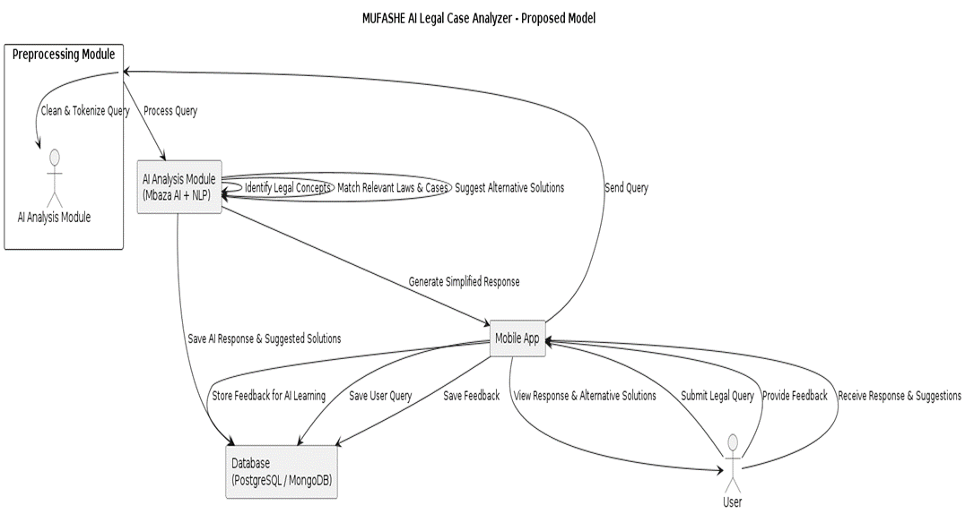

The proposed model diagram presents a high-level conceptual view of how the MUFASHE AI Legal Case Analyzer operates. It illustrates the overall flow of information from user input to system output and feedback collection.

The process begins when a user submits a legal query through the mobile application. The query undergoes preprocessing, which includes text cleaning and tokenization, to prepare it for analysis. The processed query is then analyzed by the Artificial Intelligence and Natural Language Processing module to identify relevant legal concepts and match them with applicable laws.

Based on this analysis, the system generates a simplified legal explanation and suggests alternative solutions, such as mediation or administrative procedures, where applicable. The response is delivered to the user, who can provide feedback. This feedback is stored in the system and used to improve the quality and relevance of future responses.

## ****3.4 Class Diagram****

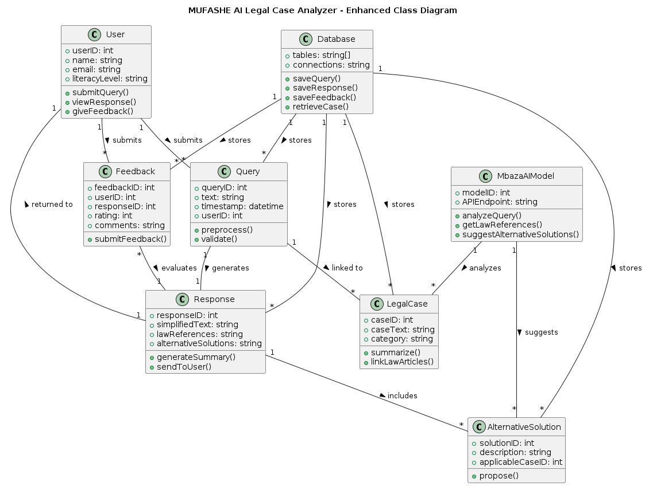

The class diagram shows the main classes of the MUFASHE system and how they relate to each other. It includes classes such as User, Query, LegalCase, Response, AlternativeSolution, Feedback, AIModel, and Database. The User submits legal queries through the Query class, which are processed by the AIModel. The system converts each query into a LegalCase and generates a Response that contains a simplified explanation, relevant law references, and alternative solutions. Users can also provide Feedback on the responses they receive. All system data are stored and managed in the Database class. This diagram explains the structure of the system and how different components interact to produce legal guidance.

## ****3.5 UML Diagrams****

### ****3.5.1 Use Case Diagram****

The use case diagram illustrates how different actors interact with the MUFASHE mobile application. The main actor is the Citizen User, who can register and log into the system, submit legal cases, upload supporting documents, view simplified explanations, see recommended next steps, and provide feedback. The user can also view case history and alternative resolution options. The System Administrator manages user accounts, reviews submitted cases, monitors system usage, and generates reports. The AI Analysis Engine(MbazaAI model ) performs the case analysis and produces explanations and recommendations. This diagram presents the main functions of the system and the roles of each actor.

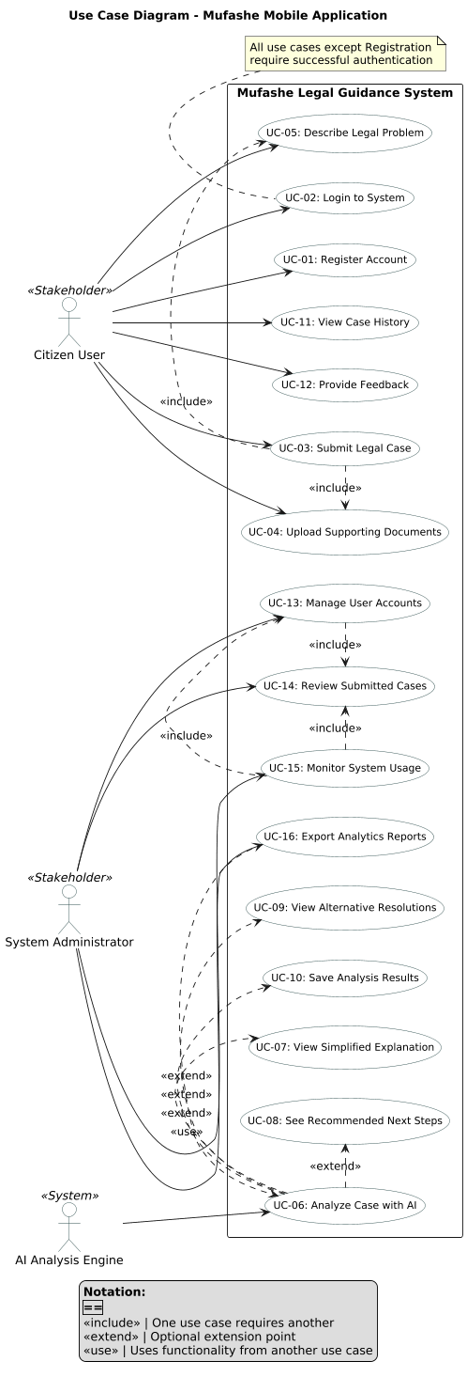

### ****3.5.2 Entity Relationship Diagram (ERD)****

The ERD shows the database structure of the MUFASHE system and how data are related. The main entities are Users, Cases, Analyses, Feedback, Laws, Precedents, and References. A user can submit many cases, and each case has one analysis. Each case can receive several feedback records. The analysis results are linked to relevant laws through the References table and may also consider legal precedents. Primary and foreign keys are used to connect the tables and maintain data integrity. This diagram explains how legal cases, system analyses, and legal sources are stored and connected in the database.

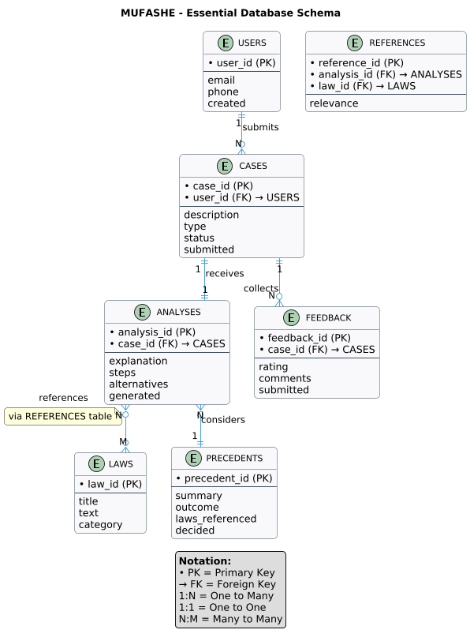

## ****3.6 System Architecture****

### ****3.6.1 Overall System Architecture****

The system architecture diagram presents the overall technical structure of the MUFASHE platform. The architecture follows a layered client–server model consisting of a mobile frontend, backend services, AI/NLP modules, and database systems hosted on cloud infrastructure.

The mobile application serves as the user interface, allowing users to submit queries and receive responses. The backend handles application logic, security, data management, and communication with the AI module. This layered architecture improves system scalability, maintainability, and security (Bass et al., 2012).

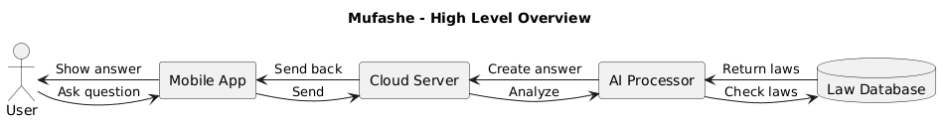

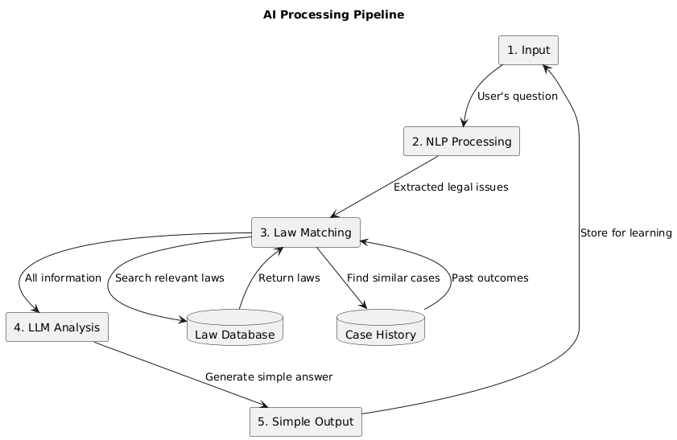

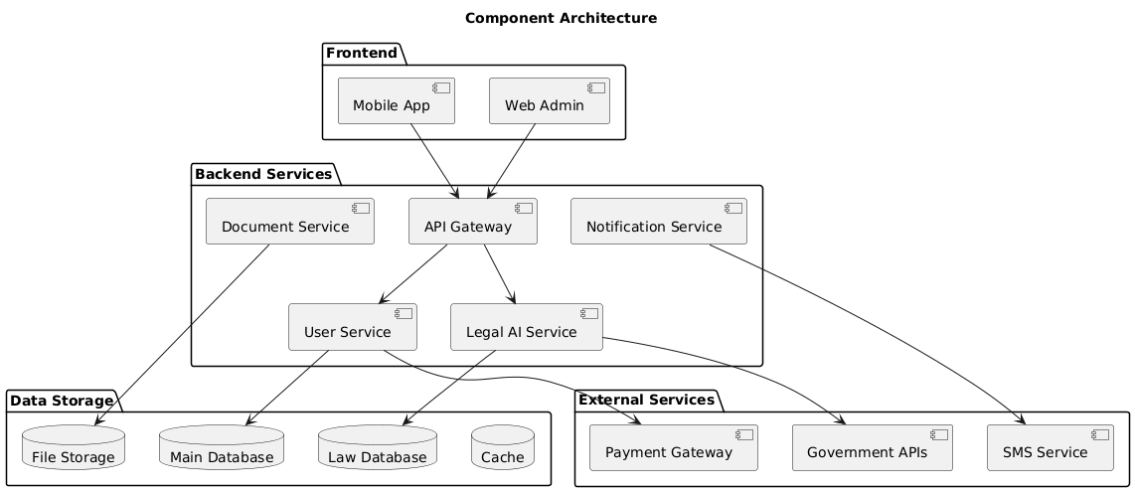

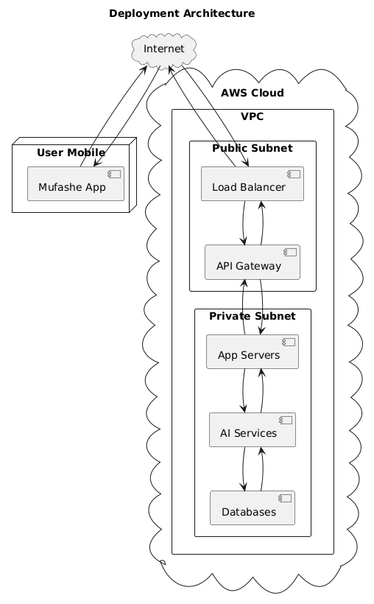

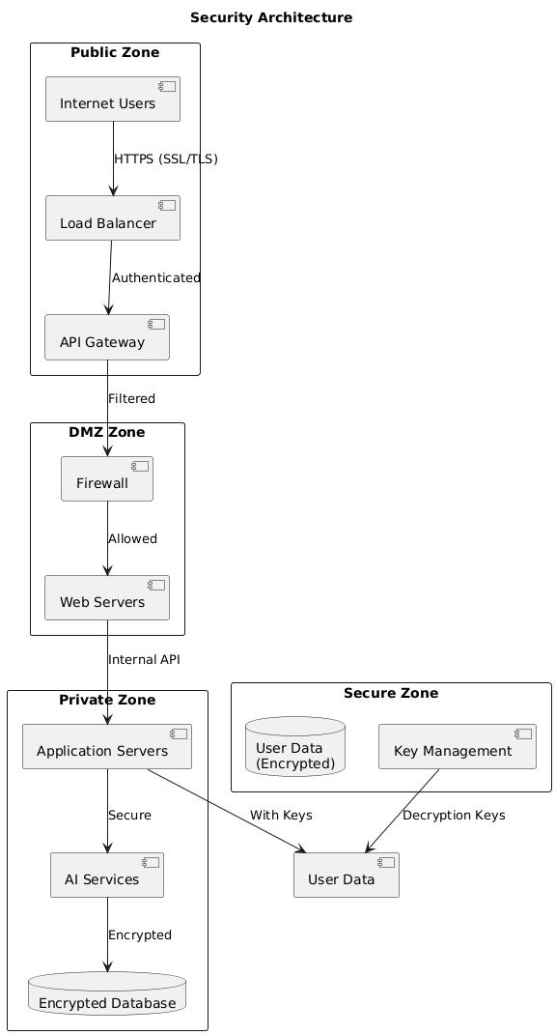

### ****3.6.2 AI/ML Pipeline Architecture****

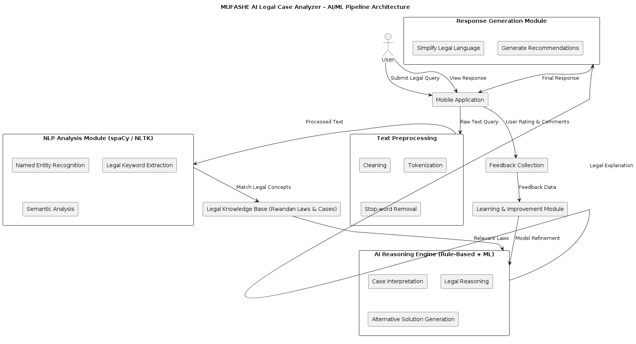

The AI/ML pipeline architecture diagram illustrates how user legal queries are processed using artificial intelligence techniques. The pipeline includes stages such as text preprocessing, semantic analysis, legal concept extraction, law matching, response generation, and feedback storage.

Natural Language Processing tools are used to interpret queries written in everyday language and map them to relevant legal information. The inclusion of a feedback loop enables continuous improvement of system responses, supporting accuracy, relevance, and explainability of AI outputs (OECD, 2025).

## ****3.7 Development Tools and Technologies****

The development of MUFASHE employs modern, scalable, and widely supported technologies suitable for mobile-first environments such as Rwanda, where mobile device usage is significantly higher than desktop usage (DataReportal, 2026). React Native is used to develop a cross-platform mobile application for Android and iOS using a single codebase. JavaScript and Node.js support frontend and backend development, enabling seamless integration across the system.

Natural Language Processing tools such as spaCy and NLTK are used to analyze legal text and interpret user queries. Databases such as PostgreSQL and MongoDB store structured legal data and unstructured user-generated content. Cloud platforms including Amazon Web Services or Microsoft Azure provide hosting, scalability, security, and monitoring services, ensuring reliable system deployment and operation.

# References

1. AllAfrica. (2025, June 8). Rwanda’s overall household internet usage reaches 30%. <https://allafrica.com/stories/202506100022.html>
2. Anu. (2025). The role of artificial intelligence in transforming legal practice and access to justice. Indian Journal of Law, 3(4), 27–30. <https://doi.org/10.36676/ijl.v3.i4.113>
3. AST Consulting. (2025). Cross platform app development using React Native. <https://astconsulting.in/app-development/cross-platform-app-react-native-5>
4. Bacancy Technology. (2025). Why use React Native for mobile apps. <https://www.bacancytechnology.com/blog/why-use-react-native>
5. Borgesano, F., De Maio, A., Laghi, P., & Musmanno, R. (2025). Artificial intelligence and justice: A systematic literature review. Journal of E Justice Innovation.
6. Chaudhary, S. (2026). Digital pathways to justice: Leveraging AI and LegalTech for underprivileged communities. Lex Localis–Journal of Local Self-Government, 22(S1), 94–115. <https://www.researchgate.net/publication/399603777>
7. DataReportal. (2026). Digital 2026: Rwanda. <https://datareportal.com/reports/digital-2026-rwanda>
8. E Sutra Technologies. (2025). The benefits of using cloud based services in app development. <https://e-sutra.com/blog/the-benefits-of-using-cloud-based-services-in-react-native-app-development>
9. Ghoshal, R. (2025). Cross border AI governance for legal tech: Standardizing ethical and legal norms in access to justice. International Journal of Law, Justice and Jurisprudence, 5(1), 186–194. <https://doi.org/10.22271/2790-0673.2025.v5.i1c.177>
10. Han, X., Li, Y., Zhang, Z., & Liu, Q. (2024). Artificial intelligence applications in legal information systems. Journal of Legal Technology, 18(2), 45–60.
11. Kalaycioglu, S., Liu, B., Hong, C., & Xie, H. (2025). AI powered legal intelligence system architecture: A comprehensive framework for automated legal consultation and analysis. arXiv. <https://arxiv.org/abs/2508.17499>
12. Legal Aid Forum. (2020). Legal awareness study in Rwanda. Kigali, Rwanda: Legal Aid Forum.
13. Magesh, V. M., Surani, F., Dahl, M., Suzgun, M., Manning, C. D., & Ho, D. E. (2024). Hallucination free? Assessing the reliability of leading AI legal research tools. arXiv. <https://arxiv.org/abs/2405.20362>
14. MoldStud. (2025). Top 10 advantages of Node.js for mobile app development. <https://moldstud.com/articles/p-top-10-reasons-to-choose-nodejs-for-your-mobile-apps-boost-performance-and-scalability>
15. Mowbray, C., Chung, D., & Greenleaf, G. (2021). Utilising AI in the legal assistance sector—Testing a role for Legal Information Institutes. Information & Communications Technology Law, 30(2), 123–140.
16. **Nuwamanya, E. (2022, November 25). Rwanda launches laws web portal.** KT Press**.** [**https://www.ktpress.rw/2022/11/rwanda-launches-laws-web-portal/**](https://www.ktpress.rw/2022/11/rwanda-launches-laws-web-portal/?utm_source=chatgpt.com)
17. Organisation for Economic Co-operation and Development. (2025). AI in justice administration and access to justice. OECD Publishing. <https://www.oecd.org/en/publications/governing-with-artificial-intelligence_795de142-en/full-report/ai-in-justice-administration-and-access-to-justice_f0cbe651.html?.com>
18. Rwanda Ministry of Justice. (2022, November 16). Rwanda launches laws web portal. KT Press. <https://www.ktpress.rw/2022/11/rwanda-launches-laws-web-portal>
19. Saadany, H., Orăsan, C., Breslin, C., Barczentewicz, M., & Walker, S. (2025). Employing AI for better access to justice: An automatic text to video linking tool for UK Supreme Court hearings. Applied Sciences, 15(16), 9205. <https://doi.org/10.3390/app15169205>
20. Statistics gov Rwanda. (2023). Education characteristics of population (literacy rates). <https://statistics.gov.rw/sites/default/files/documents/2025-02/Education.pdf>
21. Statistics gov Rwanda. (2025). Education and literacy statistics. <https://statistics.gov.rw/statistical-publications/primary-secondary-and-literacy?.com>
22. Statistics gov Rwanda. (2025). Population size and characteristics. <https://www.statistics.gov.rw/statistical-publications/population-size-and-population-characteristics>
23. Tan, J., & Benyekhlef, K. (2025). LegalWebAgent: Empowering access to justice via LLM based web agents. arXiv. <https://arxiv.org/abs/2512.04105>
24. United Nations. (2024). The rule of law at the national and international levels (A/79/226). United Nations.
25. United Nations Development Programme. (2021). Global access to justice report 2021. New York, NY: UNDP.
26. Watanabe, A. (2024). Artificial intelligence and access to justice: Technology’s role in legal systems from a human rights perspective. International Scientific Conference on AI, Human Rights, Migration, Democracy, and Public Impact. <https://www.researchgate.net/publication/395638561>